Open Ended Problem
 | Develop a library management system where indexing of book according to the author or alphabetical order can be done. Issuing of book to the student can be managed and searching of book.
  Problem Definition

BY:
ENROLLMENT NUMBER | NAME
Amisha Narsingani | 160110107031
Yashasvi parikh | 160110107036
Ankita maheshwari | 160110107025

E-R DIAGRAM:
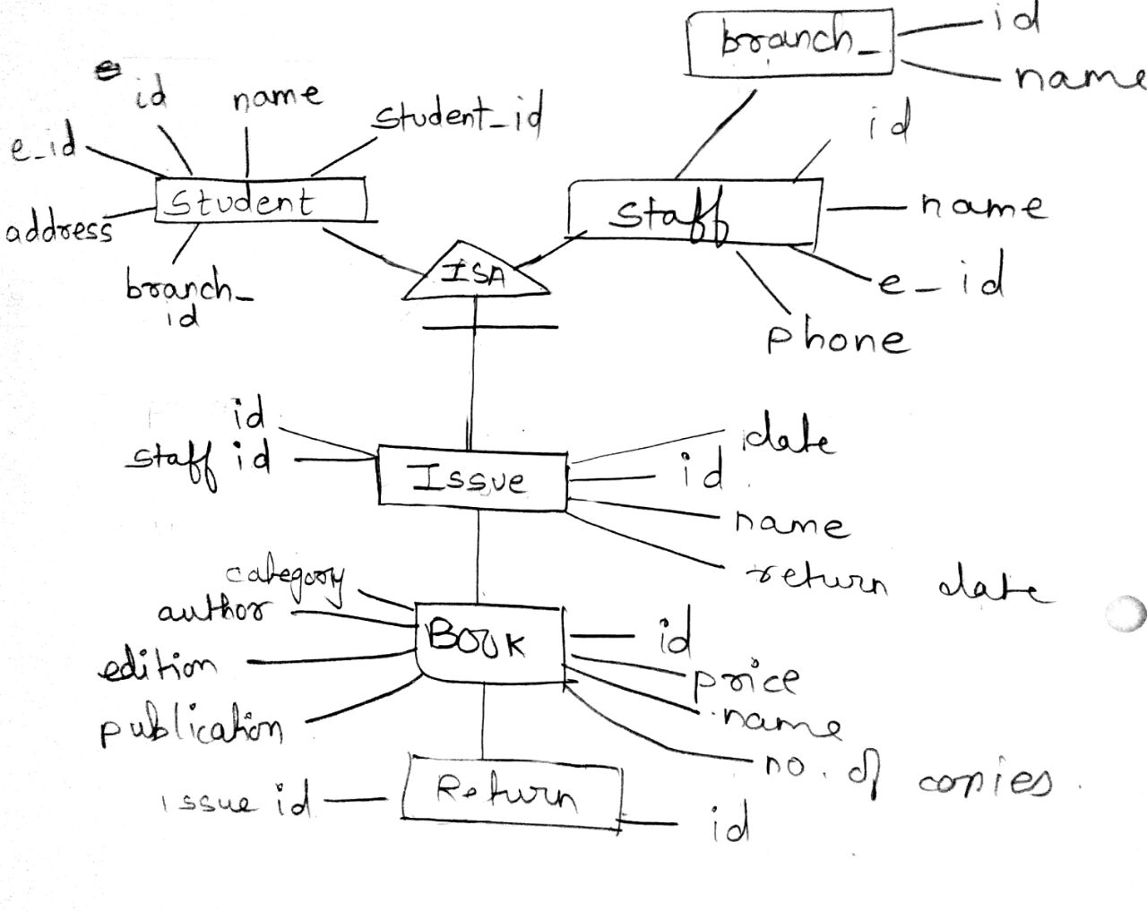
SCHEMA DIAGRAM:

DATA DICTIONARY
No of tables: 7

- Book:

- Book_category:

- Branch:

- Issue:
- Return:

- Staff:
- Student:

TABLE WITH DATA

- BOOK :

2. BOOK_CATEGORY

3. BRANCH

4. ISSUE

5. RETURN

6. STAFF

7. STUDENT

PROCEDURE:

SQL> CREATE OR REPLACE PROCEDUE PRI
2 (P_BRANCH IN STUDENT.BRANCH_ID%TYPE)
3 IS
4 BEGIN
5 DELETE FROM BRANCH WHERE BRANCH_ID=P_ID;
6 END ;
7 /

TRIGGER:

SQL> CREATE OR REPLACE TRIGGER REFRENCE
2 BEFORE INSERT OR UPDATE
3 ON BOOK FOR EACH ROW
4 WHEN (NEW.ID>0)
5 DECLARE
6 BEGIN
7 dbms_output.put_line('NEW BOOK RECORD IS ADDED');
9 END;
10 /

SQL> CREATE OR REPLACE TRIGGER NAME
2 BEFORE INSERT OR UPDATE
3 ON BOOK_NAME FOR EACH ROW
4 WHEN (NEW.NAME >0)
5 BEGIN
6 IF (CATEGORY_ID IS NULL) THEN
7 RAISE_APLLICATION_ERROR(-20399,’NULL VALUE NOT ALLOWED’);
8 END IF;
9 END;
10 /

